Copyright 2018 Carnegie Mellon University. All rights reserved.
This material is based upon work funded and supported by the Department of Defense under Contract No. FA8721-05-C-0003 with Carnegie Mellon University for the operation of the Software Engineering Institute, a federally funded research and development center.
Any opinions, findings and conclusions or recommendations expressed in this material are those of the author(s) and do not necessarily reflect the views of the United States Department of Defense.
NO WARRANTY. THIS MATERIAL IS FURNISHED ON AN “AS-IS” BASIS WITH NO WARRANTIES OF ANY KIND, EITHER EXPRESSED OR IMPLIED, INCLUDING, BUT NOT LIMITED TO, WARRANTY OF FITNESS FOR PURPOSE OR MERCHANTABILITY, ANY WARRANTY WITH RESPECT TO FREEDOM FROM PATENT, TRADEMARK, OR COPYRIGHT INFRINGEMENT, OR THIRD PARTY INTELLECTUAL PROPERTY RIGHTS.
[Distribution Statement A] This material has been approved for public release and unlimited distribution. The United States Government has Unlimited Rights in this material as defined by DFARS 252.227-7013.
The text and illustrations in this material are licensed by Carnegie Mellon University under a Creative Commons Attribution 4.0 International License.
The Creative Commons license does not extend to logos, trade marks, or service marks of Carnegie Mellon University.

Assignment Kit for
Program 5

Personal Software Process (PSP) for Engineers: Part II

The Software Engineering Institute (SEI)
is a federally funded research and development center
sponsored by the U.S. Department of Defense and
operated by Carnegie Mellon University.

This material is approved for public release.
Distribution limited by the Software Engineering Institute to attendees.

Personal Software Process for Engineers: Part II
Assignment Kit for Program 5
Overview

Overview | This assignment kit covers the following topics.
 | Section | See Page
 | Prerequisites | 2
 | Program 5 requirements | 3
 | Numerical integration with Simpson’s rule | 4
 | The t distribution | 6
 | Using the t distribution in the PSP | 6
 | An example | 9
 | Assignment instructions | 11
 | Guidelines and evaluation criteria | 20

Prerequisites | Reading  • Chapters 8 and 9

Program 5 requirements

Program 5 requirements | Using PSP2, write a program to numerically integrate a function using Simpson’s rule. Use the t distribution as the function.  Thoroughly test the program. At a minimum, calculate the values for the t distribution integral for the values in Table 1. Expected values are also included in Table 1.

Test |  | Expected Value | Actual Value
x | dof | p
0 to x= 1.1 | 9 | 0.35006
0 to x= 1.1812 | 10 | 0.36757
0 to x= 2.750 | 30 | 0.49500
Table 1

Numerical integration with Simpson’s rule

Overview | Numerical integration is the process of determining the area “under” some function.  Numerical integration calculates this area by dividing it into vertical “strips” and summing their individual areas.  The key is to minimize the error in this approximation. | 

Simpson’s rule | Simpson’s rule can be used to integrate a symmetrical statistical distribution function over a specified range (e.g., from 0 to some value x).  - num_seg = initial number of segments, an even number  - W = x/num_seg, the segment width  - E = the acceptable error, e.g., 0.00001  - Compute the integral value with the following equation.  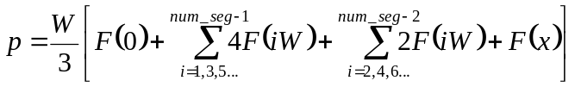  - Compute the integral value again, but this time with num_seg = num_seg*2.  - If the difference between these two results is greater than E, double num_seg and compute the integral value again. Continue doing this until the difference between the last two results is less than E. The latest result is the answer.
Continued on next page
Numerical integration with Simpson’s rule, Continued

A simple example | Let’s look at a simple function, where F(x) = 2x.  Note: This example is a triangle. The area of a triangle is  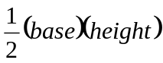  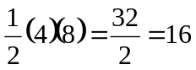 | F(x) = 2x  num_seg = 4  W = 4/4 = 1  x = 4

In this example, we can expand Simpson’s rule

to
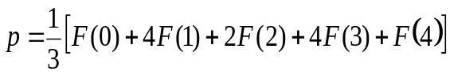
and then substitute calculated values for the function F(x)= 2x
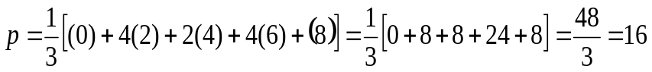

The t distribution

Overview | The t distribution is a very important statistical tool. It is used instead of the normal distribution when the true value of the population variance is not known and must be estimated from a sample.  The shape of the t distribution is dependent on the number of points in your dataset. As n gets large, the t distribution approaches the normal distribution. For lower values, it has a lower central “hump” and fatter “tails.”  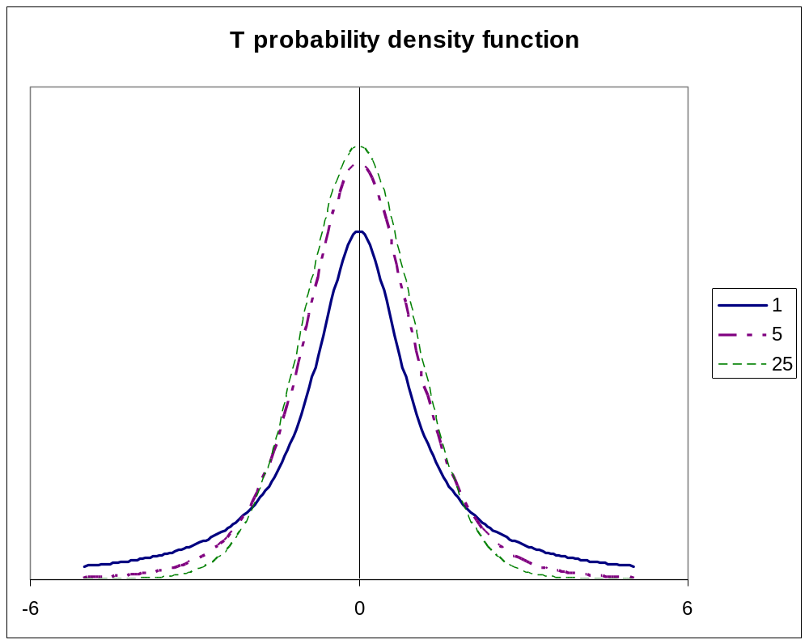

Using the  t distribution in the PSP | In the PSP the t distribution is used in two ways. We use the t distribution to test the significance of a correlation. We also use the t distribution to calculate the prediction interval when using PROBE methods A and B.
Continued on next page
The t distribution, Continued

T distribution function | When numerically integrating the t distribution with Simpson’s rule, use the following function.  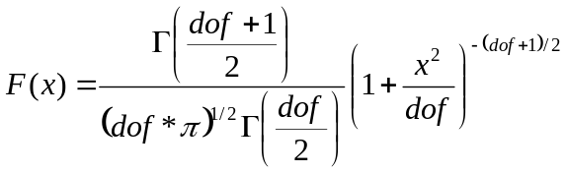  where  • dof = degrees of freedom  • Γ is the gamma function  The gamma function is  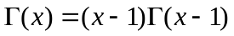, where  • 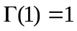  • 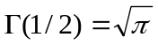
Continued on next page
The t distribution, Continued

An example of calculating gamma for an integer value | 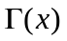for integer values is 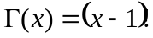.  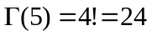

An example of calculating gamma for a non-integer value | 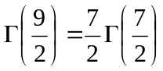  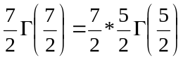  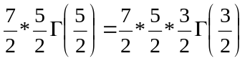  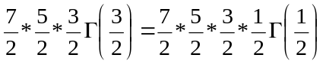  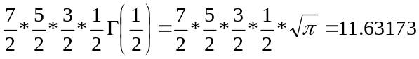

An example

An example | In this example, we’ll calculate the values for the t distribution integral from 0 to x =1.1 with 9 degrees of freedom.  - First we’ll set num_seg = 10 (any even number)  - W = x/num_seg = 1.1/10 = 0.11  - E = 0.00001  - dof = 9  - x = 1.1  - Compute the integral value with the following equation.  where  - We can solve the first part of the equation:  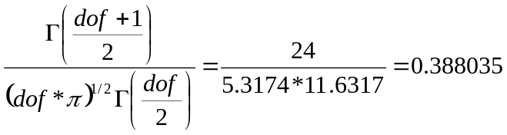  The intermediate values for this are in the Table 2.

i | x_{i} | 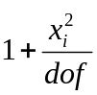 | 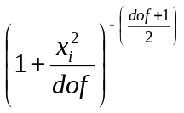 | 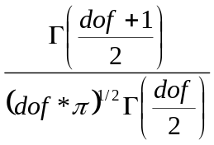 | 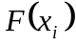 | Multiplier |  | Terms  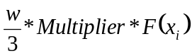
0 | 0 | 1 | 1 | 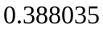 | 0.38803 | 1 |  | 0.01423
1 | 0.11 | 1.00134 | 0.9933 |  | 0.38544 | 4 |  | 0.05653
2 | 0.22 | 1.00538 | 0.97354 |  | 0.37777 | 2 |  | 0.0277
3 | 0.33 | 1.0121 | 0.94164 |  | 0.36539 | 4 |  | 0.05359
4 | 0.44 | 1.02151 | 0.89905 |  | 0.34886 | 2 |  | 0.02558
5 | 0.55 | 1.03361 | 0.84765 |  | 0.32892 | 4 |  | 0.04824
6 | 0.66 | 1.0484 | 0.78952 |  | 0.30636 | 2 |  | 0.02247
7 | 0.77 | 1.06588 | 0.72688 |  | 0.28205 | 4 |  | 0.04137
8 | 0.88 | 1.08604 | 0.66185 |  | 0.25682 | 2 |  | 0.01883
9 | 0.99 | 1.1089 | 0.5964 |  | 0.23142 | 4 |  | 0.03394
10 | 1.1 | 1.13444 | 0.53221 |  | 0.20652 | 1 |  | 0.00757
Result |  |  |  |  |  |  | 0.3500589
Table 2
Continued on next page
An example, Continued

Example, continued | - Compute the integral value again, but this time with num_seg = 20. The new result is 0.35005864.  - We compare the new result to the old result.  - 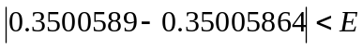  - We can then return the value p =0.35005864.

Assignment instructions

Assignment instructions | Before starting program 5, review the top-level PSP2 process script below to ensure that you understand the “big picture” before you begin. Also, ensure that you have all of the required inputs before you begin the planning phase.

PSP2 Process Script

Purpose | To guide the development of module-level programs
Entry Criteria | - Problem description  - PSP2 Project Plan Summary form  - Size Estimating template  - Historical size and time data (estimated and actual)  - Time and Defect Recording logs  - Defect Type, Coding, and Size Counting standards  - Stopwatch (optional)

Step | Activities | Description
1 | Planning | - Produce or obtain a requirements statement.  - Use the PROBE method to estimate the added and modified size of this program.  - Complete the Size Estimating template.  - Use the PROBE method to estimate the required development time.  - Complete a Task Planning template.  - Complete a Schedule Planning template.  - Enter the plan data in the Project Plan Summary form.  - Complete the Time Recording log.
2 | Development | - Design the program.  - Review the design, and fix and log all defects found.  - Implement the design.  - Review the code, and fix and log all defects found.  - Compile the program, and fix and log all defects found.  - Test the program, and fix and log all defects found.  - Complete the Time Recording log.
3 | Postmortem | Complete the Project Plan Summary form with actual time, defect, and size data.

Exit Criteria | - A thoroughly tested program  - Completed Project Plan Summary form with estimated and actual data  - Completed Size Estimating and Task and Schedule Planning templates  - Completed Design Review and Code Review checklists  - Completed Test Report template  - Completed PIP forms  - Completed Time and Defect Recording logs

Continued on next page
Assignment instructions, Continued

Planning phase | Plan program 5 following the PSP2 planning phase and the PROBE estimating scripts.

PSP2 Planning Script

Purpose | To guide the PSP planning process
Entry Criteria | - Problem description  - PSP2 Project Plan Summary form  - Size Estimating, Task Planning, and Schedule Planning templates  - Historical size and time data (estimated and actual)  - Time Recording log

Step | Activities | Description
1 | Program  Requirements | - Produce or obtain a requirements statement for the program.  - Ensure that the requirements statement is clear and unambiguous.  - Resolve any questions.
2 | Size  Estimate | - Produce a program conceptual design.  - Use the PROBE method to estimate the added and modified size of this program.  - Complete the Size Estimating template and Project Plan Summary form.
3 | Resource  Estimate | - Use the PROBE method to estimate the time required to develop this program.  - Using the To Date % from the most recently developed program as a guide, distribute the development time over the planned project phases. (Note: This step is completed by the SEI student workbook.)
4 | Task and  Schedule Planning | For projects lasting several days or more, complete the Task Planning and Schedule Planning templates.
5 | Defect  Estimate | - Based on your to-date data on defects per added and modified size unit, estimate the total defects to be found in this program.  - Based on your To Date % data, estimate the number of defects to be injected and removed by phase.

Exit Criteria | - Documented requirements statement  - Program conceptual design  - Completed Size Estimating template  - For projects lasting several days or more, completed Task and Schedule Planning templates  - Completed Project Plan Summary form with estimated program size, development time, and defect data  - Completed Time Recording log

Verify that you have met all of the exit criteria for the planning phase, then have an instructor review your plan. After your plan has been reviewed, proceed to the development phase.
Continued on next page

Assignment instructions, Continued
Use the PROBE method to create size and resource estimates.

PROBE Estimating Script

Purpose | To guide the size and time estimating process using the PROBE method
Entry Criteria | - Requirements statement  - Size Estimating template and instructions  - Size per item data for part types  - Time Recording log  - Historical size and time data
General | - This script assumes that you are using added and modified size data as the size-accounting types for making size and time estimates.  - If you choose some other size-accounting types, replace every “added and modified” in this script with the size-accounting types of your choice.

Step | Activities | Description
1 | Conceptual Design | Review the requirements and produce a conceptual design.
2 | Parts Additions | Follow the Size Estimating Template instructions to estimate the parts additions and the new reusable parts sizes.
3 | Base Parts and Reused Parts | - For the base program, estimate the size of the base, deleted, modified, and added code.  - Measure and/or estimate the size of the parts to be reused.
4 | Size Estimating Procedure | - If you have sufficient estimated proxy size and actual added and modified size data (three or more points that correlate), use procedure 4A.  - If you do not have sufficient estimated data but have sufficient plan added and modified and actual added and modified size data (three or more points that correlate), use procedure 4B.  - If you have insufficient data or they do not correlate, use procedure 4C.  - If you have no historical data, use procedure 4D.
4A | Size Estimating Procedure 4A | - Using the linear-regression method, calculate the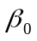and 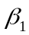 parameters from the estimated proxy size and actual added and modified size data.  - If the absolute value ofis not near 0 (less than about 25% of the expected size of the new program), or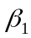is not near 1.0 (between about 0.5 and 2.0), use procedure 4B.
4B | Size Estimating Procedure 4B | - Using the linear-regression method, calculate theandparameters from the plan added and modified size and actual added and modified size data.  - If the absolute value of is not near 0 (less than about 25% of the expected size of the new program), oris not near 1.0 (between about 0.5 and 2.0), use procedure 4C.
4C | Size Estimating Procedure 4C | If you have any data on plan added and modified size and actual added and modified size, set= 0 and = (actual total added and modified size to date/plan total added and modified size to date).
4D | Size Estimating Procedure 4D | If you have no historical data, use your judgment to estimate added and modified size.
(continued)

Continued on next page

Assignment instructions, Continued
PROBE Estimating Script (Continued)

Step | Activities | Description
5 | Time Estimating Procedure | - If you have sufficient estimated proxy size and actual development time data (three or more points that correlate), use procedure 5A.  - If you do not have sufficient estimated size data but have sufficient plan added and modified size and actual development time data (three or more points that correlate), use procedure 5B.  - If you have insufficient data or they do not correlate, use procedure 5C.  - If you have no historical data, use procedure 5D.
5A | Time Estimating Procedure 5A | - Using the linear-regression method, calculate theand parameters from the estimated proxy size and actual total development time data.  - Ifis not near 0 (substantially smaller than the expected development time for the new program), oris not within 50% of 1/(historical productivity), use procedure 5B.
5B | Time Estimating Procedure 5B | - Using the linear-regression method, calculate theand regression parameters from the plan added and modified size and actual total development time data.  - Ifis not near 0 (substantially smaller than the expected development time for the new program), oris not within 50% of 1/(historical productivity), use procedure 5C.
5C | Time Estimating Procedure 5C | - If you have data on estimated – added and modified size and actual development time, set= 0 and = (actual total development time to date/estimated – total added and modified size to date).  - If you have data on plan – added and modified size and actual development time, set= 0 and = (actual total development time to date/plan total added and modified size to date).  - If you only have actual time and size data, set= 0 and = (actual total development time to date/actual total added and modified size to date).
5D | Time Estimating Procedure 5D | If you have no historical data, use your judgment to estimate the development time from the estimated added and modified size.
6 | Time and Size Prediction Intervals | - If you used regression method A or B, calculate the 70% prediction intervals for the time and size estimates.  - If you did not use the regression method or do not know how to calculate the prediction interval, calculate the minimum and maximum development time estimate limits from your historical maximum and minimum productivity for the programs written to date.

Exit Criteria | - Completed estimated and actual entries for all pertinent size categories  - Completed PROBE Calculation Worksheet with size and time entries  - Plan and actual values entered on the Project Plan Summary
Continued on next page
Assignment instructions, Continued

Development phase | Develop the program following the PSP2 development phase script.
PSP2 Development Script

Purpose | To guide the development of small programs
Entry Criteria | - Requirements statement  - Project Plan Summary form with estimated program size and development time  - For projects lasting several days or more, completed Task Planning and Schedule Planning templates  - Time and Defect Recording logs  - Defect Type standard and Coding standard

Step | Activities | Description
1 | Design | - Review the requirements and produce a design to meet them.  - Record in the Defect Recording log any requirements defects found.  - Record time in the Time Recording log.
2 | Design  Review | - Follow the Design Review script and checklist to review the design.  - Fix all defects found.  - Record defects in the Defect Recording log.  - Record time in the Time Recording log.
3 | Code | - Implement the design following the Coding standard.  - Record in the Defect Recording log any requirements or design defects found.  - Record time in the Time Recording log.
4 | Code  Review | - Follow the Code Review script and checklist to review the code.  - Fix all defects found.  - Record defects in the Defect Recording log.  - Record time in the Time Recording log.
5 | Compile | - Compile the program until there are no compile errors.  - Fix all defects found.  - Record defects in the Defect Recording log.  - Record time in the Time Recording log.
6 | Test | - Test until all tests run without error.  - Fix all defects found.  - Record defects in the Defect Recording log.  - Record time in the Time Recording log.  - Complete a Test Report template on the tests conducted and the results obtained.

Exit Criteria | - A thoroughly tested program that conforms to the Coding standard  - Completed Design Review and Code Review checklists  - Completed Test Report template  - Completed Time and Defect Recording logs

Verify that you have met all of the exit criteria for the development phase, then proceed to the postmortem phase.
Continued on next page
Assignment instructions, Continued

 | Design  review |  | Review your designs following the PSP2 design review script.
PSP2 Design Review Script

 |  | Purpose |  | To guide you in reviewing detailed designs
 |  | Entry Criteria |  | - Completed program design  - Design Review checklist  - Design standard  - Defect Type standard  - Time and Defect Recording logs
 |  | General |  | Where the design was previously verified, check that the analyses  - covered all of the design  - were updated for all design changes  - are correct  - are clear and complete

Step | Activities | Description
1 | Preparation | Examine the program and checklist and decide on a review strategy.
2 | Review | - Follow the Design Review checklist.  - Review the entire program for each checklist category; do not try to review for more than one category at a time!  - Check off each item as you complete it.  - Complete a separate checklist for each product or product segment reviewed.
3 | Fix Check | - Check each defect fix for correctness.  - Re-review all changes.  - Record any fix defects as new defects and, where you know the defective defect number, enter it in the fix defect space.

Exit Criteria | - A fully reviewed detailed design  - One or more Design Review checklists for every design reviewed  - All identified defects fixed and all fixes checked  - Completed Time and Defect Recording logs

Continued on next page

Assignment instructions, Continued

 | Code  review |  | Review your code following the code review script.
Code Review Script

 |  | Purpose |  | To guide you in reviewing programs
 |  | Entry Criteria |  | - A completed and reviewed program design  - Source program listing  - Code Review checklist  - Coding standard  - Defect Type standard  - Time and Defect Recording logs
 |  | General |  | Do the code review with a source-code listing; do not review on the screen!

Step | Activities | Description
1 | Review | - Follow the Code Review checklist.  - Review the entire program for each checklist category; do not try to review for more than one category at a time!  - Check off each item as it is completed.  - For multiple procedures or programs, complete a separate checklist for each.
2 | Correct | - Correct all defects.  - If the correction cannot be completed, abort the review and return to the prior process phase.  - To facilitate defect analysis, record all of the data specified in the Defect Recording log instructions for every defect.
3 | Check | - Check each defect fix for correctness.  - Re-review all design changes.  - Record any fix defects as new defects and, where you know the number of the defect with the incorrect fix, enter it in the fix defect space.

Exit Criteria | - A fully reviewed source program  - One or more Code Review checklists for every program reviewed  - All identified defects fixed  - Completed Time and Defect Recording logs
Continued on next page
Assignment instructions, Continued

Postmortem  phase | Conduct the postmortem following the PSP2 postmortem script.

PSP2 Postmortem Script

Purpose | To guide the PSP postmortem process
Entry Criteria | - Problem description and requirements statement  - Project Plan Summary form with program size, development time, and defect data  - For projects lasting several days or more, completed Task Planning and Schedule Planning templates  - Completed Test Report template  - Completed Design Review and Code Review checklists  - Completed Time and Defect Recording logs  - A tested and running program that conforms to the coding and size counting standards

Step | Activities | Description
1 | Defect Recording | - Review the Project Plan Summary to verify that all of the defects found in each phase were recorded.  - Using your best recollection, record any omitted defects.
2 | Defect Data Consistency | - Check that the data on every defect in the Defect Recording log are accurate and complete.  - Verify that the numbers of defects injected and removed per phase are reasonable and correct.  - Determine the process yield and verify that the value is reasonable and correct.  - Using your best recollection, correct any missing or incorrect defect data.
3 | Size | - Count the size of the completed program.  - Determine the size of the base, deleted, modified, base additions, reused, new reusable code, and added parts.  - Enter these data in the Size Estimating template.  - Determine the total program size  - Enter this data in the Project Plan Summary form.
4 | Time | - Review the completed Time Recording log for errors or omissions.  - Using your best recollection, correct any missing or incomplete time data.

Exit Criteria | - A thoroughly tested program that conforms to the coding and size counting standards  - Completed Design Review and Code Review checklists  - Completed Test Report template  - Completed Project Plan Summary form  - Completed PIP forms describing process problems, improvement suggestions, and lessons learned  - Completed Time and Defect Recording logs

Verify that you have met all of the exit criteria for the PSP2 postmortem phase, then submit your assignment.
Continued on next page
Assignment instructions, Continued

Submitting your assignment | When you’ve completed the postmortem phase, submit your assignment package, source code, and test results to the instructor.  The order for the assignment package is  • PSP2 Project Plan Summary form  • Test Report template  • PSP2 Design Review checklist  • Code Review checklist  • PIP form  • Size Estimating template  • PROBE Calculation worksheet  • Time Recording log  • Defect Recording log  • source program listing  • test results

Guidelines and evaluation criteria for program 5

Evaluation  criteria | Your process report must be  • complete  • legible  • in the specified order | Your process data must be  • accurate  • precise  • self-consistent

Suggestions | Remember, you should complete this assignment today.  Keep your programs simple. You will learn as much from developing small programs as from large ones.  If you are not sure about something, ask your instructor for clarification.  Software is not a solo business, so you do not have to work alone.  - You must, however, produce your own estimates, designs, code, and completed forms and reports.  - You may have others review your work, and you may change it as a result.  - You should note any help you receive from others in your process report. Log the review time that you and your associates spend, and log the defects found or any changes made.

